Project Documentation
On

Voice-Based Email & Messaging Assistant
Hands-Free Communication for All

Author/ Developer: Abhinav Gupta
Mentor/Supervisor: Dr. K Santhiya
Submission Date: 13-01-2026

ABSTRACT
The Voice-Based Email & Messaging Assistant is an accessibility-focused application designed to enable users to perform email operations using only voice commands. The primary objective of this system is to assist visually impaired users, elderly individuals, and users with physical disabilities who find it difficult to interact with conventional email platforms that rely on keyboards, mice, and visual interfaces.

The system integrates Speech-to-Text (STT) technology to convert spoken user commands into text and Text-to-Speech (TTS) technology to provide audible feedback by reading emails, system prompts, and notifications aloud. By leveraging the Gmail API, the application allows users to securely log in, read inbox emails, compose new messages, reply to existing emails, and delete emails without any manual input.

The application follows a modular architecture where voice input is captured through a microphone, processed using speech recognition models, interpreted by a command-processing module, and executed through backend services connected to the email server. The output is then conveyed back to the user through synthesized speech, ensuring a completely hands-free experience.
This project demonstrates how modern voice technologies and cloud-based APIs can be combined to enhance digital accessibility, reduce dependency on traditional input devices, and promote inclusive communication. The Voice-Based Email & Messaging Assistant provides an efficient, user-friendly, and scalable solution for hands-free email interaction and serves as a step toward more inclusive human–computer interaction systems.

ACKNOWLEDGEMENT

I would like to express my sincere gratitude to Infosys Springboard for providing the opportunity and platform to work on the project titled “Voice-Based Email & Messaging Assistant”. The structured learning resources, guidance, and support offered through this program played a vital role in the successful completion of this project.

I would like to extend my heartfelt thanks to my project mentor and instructors for their valuable guidance, continuous support, and constructive feedback throughout the development of this project. Their encouragement and insights helped me to understand the concepts clearly and implement them effectively.

I am also grateful to my faculty members for their motivation and academic support, which helped me stay focused and disciplined during the project work.

Finally, I would like to thank my family and friends for their constant encouragement, patience, and moral support, which inspired me to complete this project successfully.

TABLE OF CONTENTS

- Cover Page
- Abstract
- Acknowledgement
- Chapter 1: Introduction
1.1 Project Overview
1.2 Problem Statement
1.3 Objectives
- Chapter 2: Literature Survey & Technology Stack
2.1 Literature Survey
2.2 Frontend: Streamlit
2.3 Backend: Python & Flask
2.4 Database: SQLite
2.5 APIs & Tools: Gmail API, Speech-to-Text, Text-to-Speech
- Chapter 3: System Design & Architecture
3.1 System Architecture
3.2 Database Design
3.3 Workflow Diagram (Voice Command Processing)
- Chapter 4: System Implementation
4.1 User Registration & Authentication
4.2 Login Dashboard
4.3 Voice-Controlled Email Dashboard
4.4 Database Design
- Chapter 5: Results & Discussion
5.1 Output Screenshots
5.2 Performance Analysis
5.3 Accessibility Evaluation
- Chapter 6: Advantages, Limitations & Future Scope
6.1 Advantages
6.2 Limitations
6.3 Future Enhancements
- Chapter 7: Conclusion

Chapter 1: Introduction
  - Project Overview
The Voice-Based Email & Messaging Assistant is an accessibility-oriented application that allows users to perform email-related tasks using voice commands instead of traditional input devices such as a keyboard and mouse. The project is mainly designed to assist visually impaired users, elderly individuals, and users with physical disabilities who face difficulties while using conventional email systems.
The system uses Speech-to-Text (STT) technology to convert spoken commands into text and Text-to-Speech (TTS) technology to provide audio feedback to the user. By integrating these technologies with the Gmail API, users can securely access their email accounts and perform operations such as reading inbox emails, composing new emails, replying to messages, and deleting emails through voice instructions.
The application follows a user-friendly and modular design that ensures smooth interaction between the user and the system. All operations are performed in real time, making the communication process faster, more efficient, and completely hands-free.
  - Problem Statement
Despite the widespread use of email as a primary communication medium, most email platforms rely heavily on graphical user interfaces that require visual attention and manual input. This creates significant challenges for visually impaired users and individuals with motor disabilities.
Although screen readers and accessibility tools exist, they are often complex, expensive, or provide limited functionality. Users must still rely on keyboard shortcuts or external assistance, which reduces independence and efficiency.
Therefore, there is a need for a simple, integrated, and reliable voice-based email system that allows users to access and manage emails independently using natural voice commands.
  - Objectives
The main objectives of this project are:
- To design and develop a fully voice-controlled email system
- To provide hands-free access to email services
- To assist visually impaired and physically challenged users
- To integrate Speech-to-Text and Text-to-Speech technologies effectively
- To enable users to read, compose, reply to, and delete emails using voice commands
- To ensure secure authentication and data privacy

Chapter 2: Literature Survey & Technology Stack
2.1 Literature Survey
Previous research shows that voice-based systems improve accessibility for visually impaired users. Advances in Speech-to-Text and Text-to-Speech technologies have increased accuracy and usability. However, existing voice-based email systems often lack full functionality or strong security, creating the need for an integrated solution.
2.2 Frontend: Streamlit
Streamlit is used as the frontend framework in this project to create an interactive and user-friendly interface. It allows rapid development of web applications using Python without requiring extensive frontend coding.
Streamlit provides built-in components such as buttons, text areas, and audio support, making it suitable for voice-based applications. It also enables real-time interaction between the user and the backend, which is essential for processing voice commands efficiently.
2.3 Backend: Python & Flask
Python is used as the core programming language due to its simplicity, extensive libraries, and strong support for artificial intelligence and speech processing.
Flask is used as the backend framework to handle application logic, API integration, and request handling. It enables smooth communication between the frontend, speech processing modules, and the Gmail API.
2.4 Database: SQLite
The database is used to store user-related information such as login credentials, authentication tokens, and activity logs.
- SQLite is suitable for lightweight, local storage and testing.
2.5 APIs & Tools
- Gmail API
The Gmail API is used to access and manage user emails securely. It enables operations such as fetching inbox emails, sending new emails, replying, and deleting messages.
- Speech-to-Text (STT)
Speech-to-Text technology converts spoken commands into text. Models such as Whisper or Google Speech Recognition are used to ensure high accuracy.
- Text-to-Speech (TTS)
Text-to-Speech technology converts system responses and email content into audible speech, allowing users to hear email details and system prompts.
- OAuth 2.0
OAuth 2.0 is used for secure authentication and authorization, ensuring that user data and email access remain protected.
Chapter 3: System Design & Architecture
3.1 System Architecture
The Voice-Based Email & Messaging Assistant follows a modular and layered architecture to ensure smooth communication between different system components. Each module performs a specific task, which improves system reliability, scalability, and maintainability.
The overall architecture consists of the following main components:
- User Interface (Frontend)
The frontend is developed using Streamlit and acts as the interaction layer between the user and the system. It displays system prompts and captures voice input from the user through a microphone.
- Speech Processing Module
This module includes:
  - Speech-to-Text (STT): Converts spoken user commands into text.
  - Text-to-Speech (TTS): Converts system responses and email content into audible speech.
- Application Logic (Backend)
The backend processes the converted text, identifies user intent, and triggers appropriate email operations such as reading, composing, or deleting emails.
- Email Service (Gmail API)
The Gmail API handles secure communication with the user’s email account using OAuth 2.0 authentication.
- Database
The database stores user credentials, authentication tokens, and system logs.
This architecture ensures a completely hands-free and user-friendly email experience.
3.2 Database Design
The database is designed to securely store user-related information and system data.
User Table / Collection
- Username
- Google APP Password
- Face Image
- Gmail Token

3.3 Workflow Diagram (Voice Command Processing)
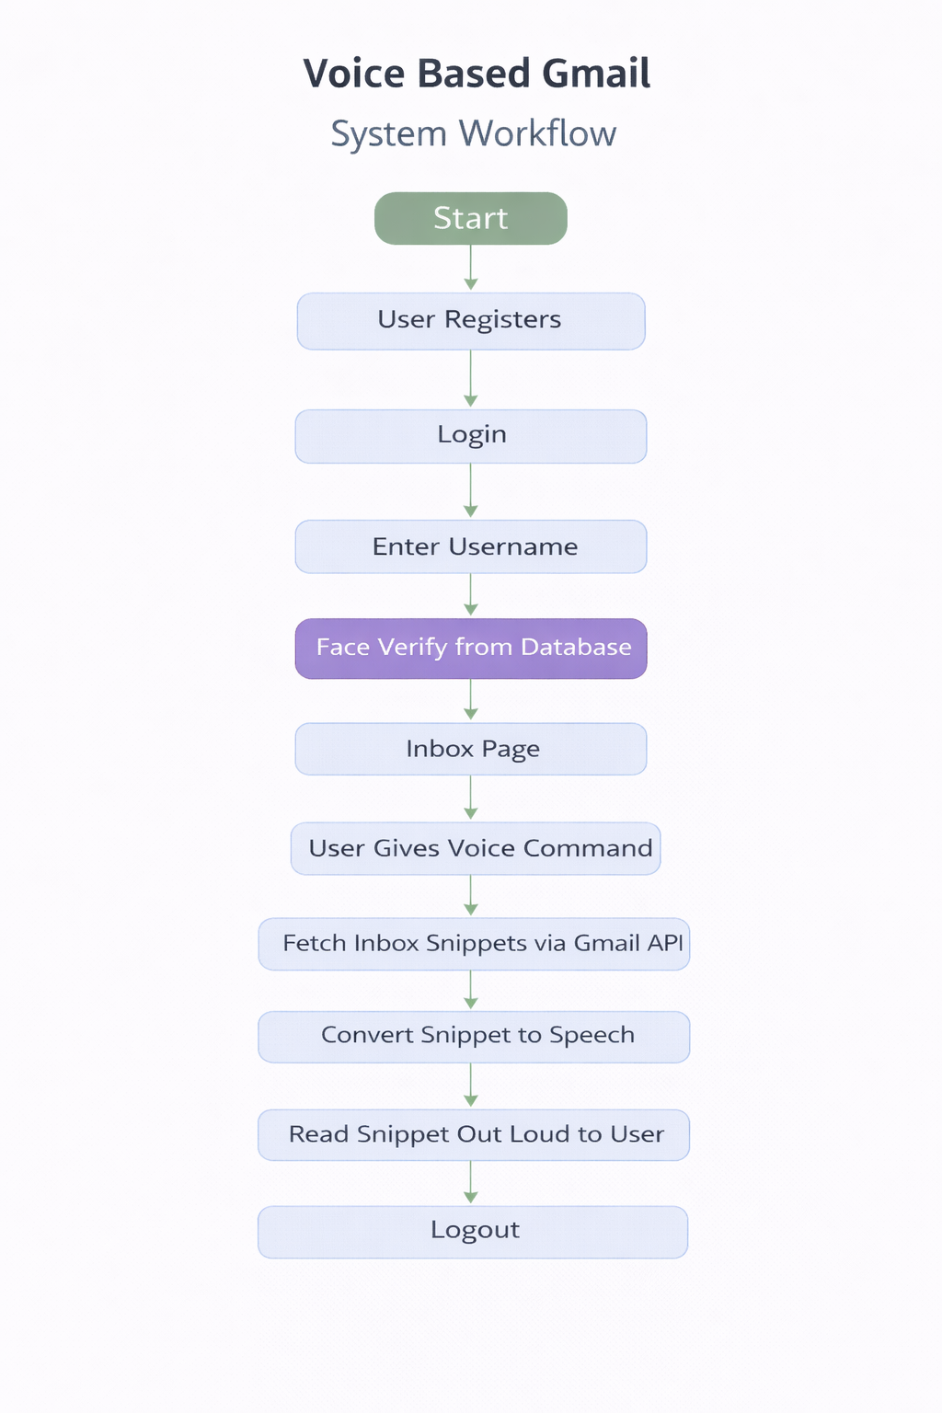

Chapter 4: System Implementation
- User Registration & Authentication
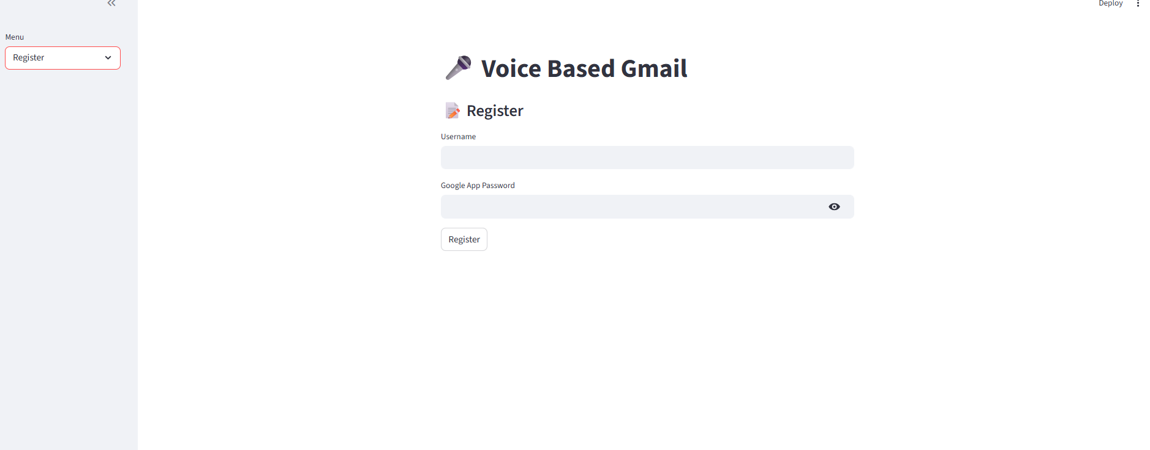
Description : This screen shows the registration interface where users provide their credentials and register their facial data for secure face-based login.
- Login Dashboard
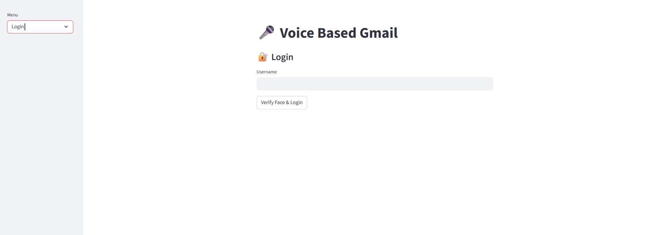
Description : This screen shows the login interface where users authenticate using username and face verification before accessing the voice-based email system.

4.3 Voice-Controlled Email Dashboard
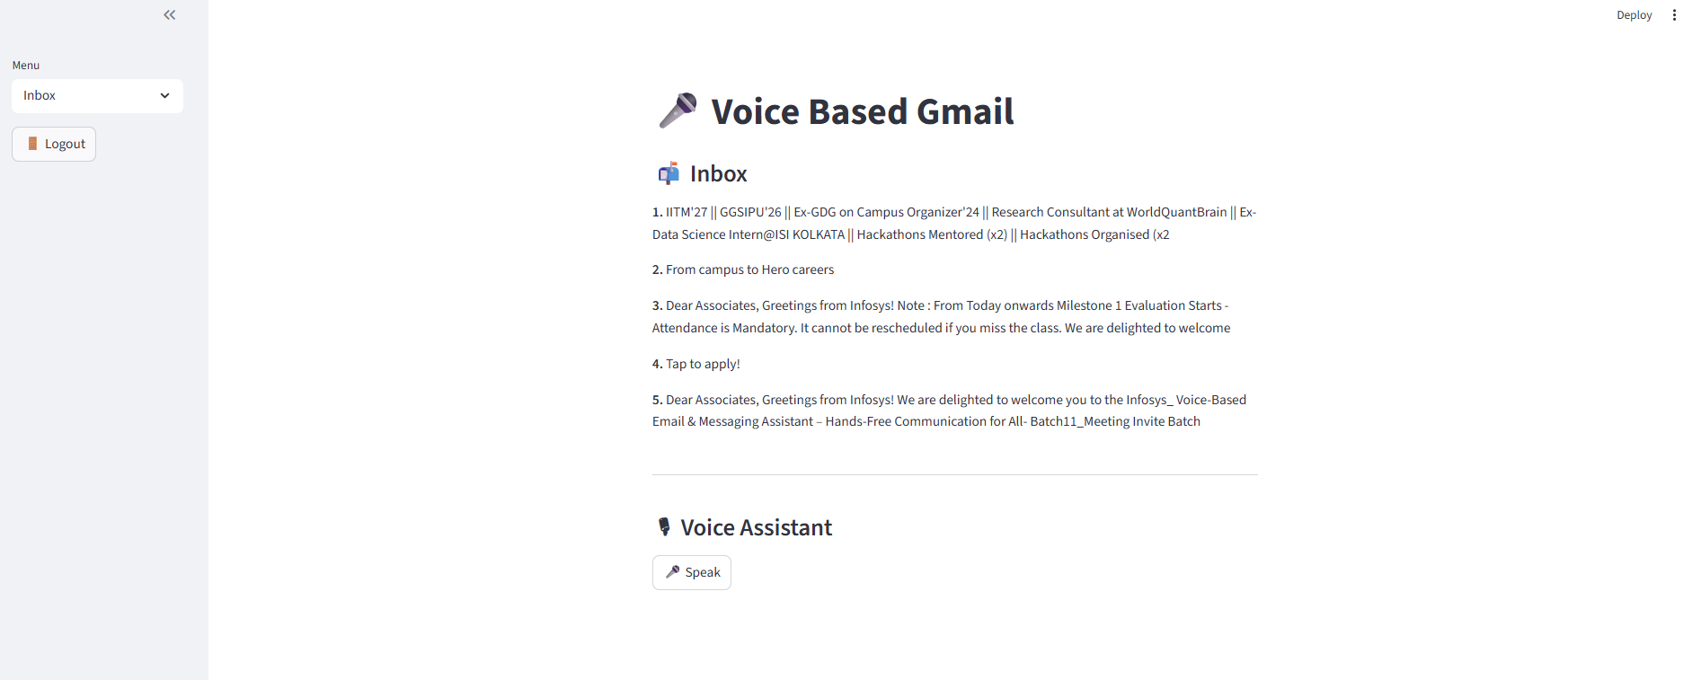
Description: This screen shows the inbox view where emails are listed and managed using voice commands through the integrated voice assistant.
4.4 Database Design
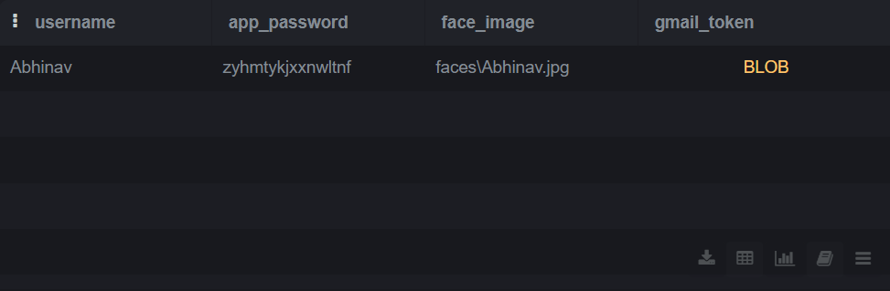
Description:
The database table contains the following fields:
- Username: Stores the unique username of the registered user.
- App Password: Stores the Google App Password required for secure access to the Gmail API.
- Face Image: Stores the file path of the user’s registered facial image, which is used for face verification during login.
- Gmail Token: Stores the OAuth authentication token in encrypted (BLOB) format, enabling secure and authorized access to the user’s Gmail account.
Chapter 5: Results & Discussion

5.1 System Output Results
The Voice-Based Email & Messaging Assistant was successfully implemented and tested. The system accurately performed all major email operations using voice commands. Users were able to register, log in using face verification, access their inbox, read emails aloud, compose new emails, reply to messages, and delete emails without using a keyboard or mouse.
The application fetched real-time emails using the Gmail API and displayed them correctly in the inbox interface. Voice commands were processed efficiently, and system responses were delivered through clear audio feedback.
5.2 Speech Recognition Performance
The Speech-to-Text module demonstrated good accuracy in recognizing user commands, especially in low-noise environments. Common voice commands such as reading emails, navigating inbox items, and composing messages were recognized successfully.
Minor inaccuracies were observed when there was background noise or unclear speech, but these did not significantly affect overall system functionality.
5.3 Response Time Analysis
The system responded quickly to user commands. Email operations such as fetching inbox messages, reading emails, and sending emails were executed with minimal delay. The response time mainly depended on internet connectivity and Gmail API response speed.
5.4 Security and Authentication Results
The face verification feature worked effectively and provided an additional layer of security during login. Only registered users with matching facial data were able to access the system, ensuring protection against unauthorized access.

Chapter 6: Advantages, Limitations & Future Scope
6.1 Advantages
The Voice-Based Email & Messaging Assistant offers several advantages, especially in terms of accessibility and ease of use:
- Provides hands-free email access, eliminating the need for keyboard and mouse
- Highly beneficial for visually impaired and physically challenged users
- Simple and user-friendly interface with voice guidance
- Secure authentication with face verification
- Reduces dependency on third-party screen readers
- Saves time and improves user convenience

6.2 Limitations
Despite its effectiveness, the system has certain limitations:
- Requires a stable internet connection for email and speech processing
- Speech recognition accuracy may decrease in noisy environments
- Performance depends on microphone quality
- Gmail API usage is subject to API limits and permissions
- Currently supports limited language options

6.3 Future Scope
The project can be enhanced in several ways to improve functionality and scalability:
- Implementation of multilingual support
- Integration with WhatsApp, SMS, and other messaging platforms
- Offline Speech-to-Text processing
- AI-based email summarization and prioritization
- Improved noise-reduction techniques
- Emotion-aware voice responses for better user experience

Chapter 7: Conclusion
The Voice-Based Email & Messaging Assistant successfully demonstrates the use of voice technologies to improve accessibility and usability in digital communication. The system enables users to perform essential email operations such as reading, composing, replying to, and deleting emails using voice commands, without relying on traditional input devices like a keyboard or mouse.
By integrating Speech-to-Text, Text-to-Speech, Gmail API, and face verification, the application provides a secure, hands-free, and user-friendly email experience. The project effectively addresses the challenges faced by visually impaired users and individuals with physical disabilities, promoting inclusive and independent communication.
The results show that voice-based interaction can serve as a practical and efficient alternative to conventional email systems. Although the system has certain limitations related to internet dependency and speech recognition accuracy, these can be overcome with future enhancements.
Overall, the project meets its objectives and highlights the potential of voice-driven applications in building accessible and inclusive technology solutions.

